Name:_____________________________________________ ipad__________

TOPIC #15

REDOX AND

ELECTROCHEMISTRY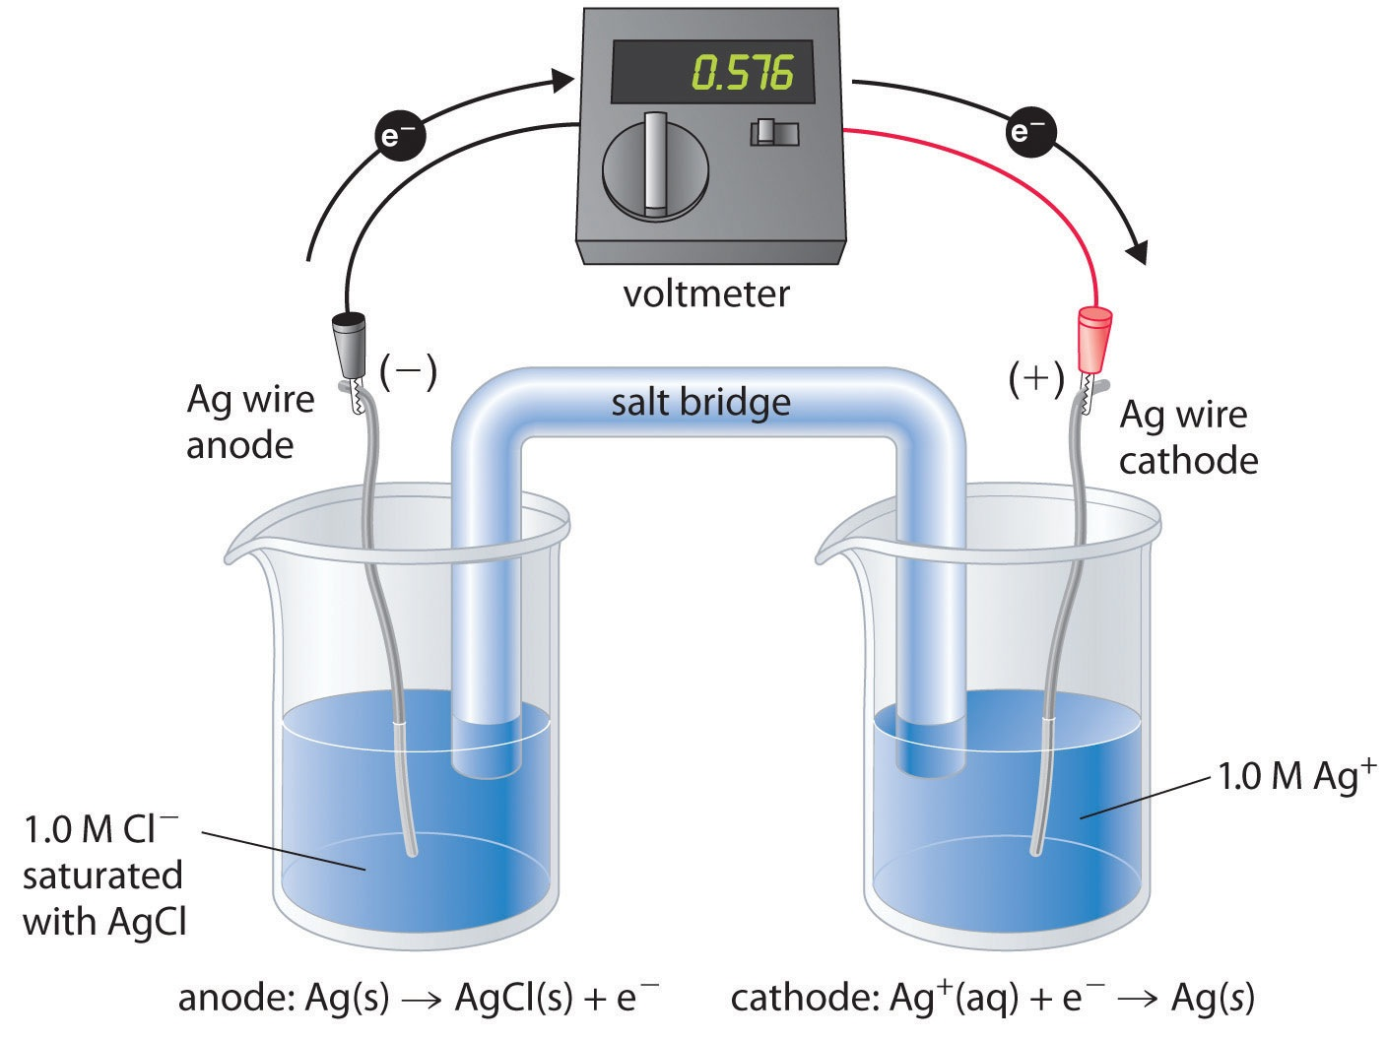

Homework Due: ______________________

Exam: FR:______________________

MC:_______________________

TEXTBOOK: Chapters 20 and 21

Topic #15 Study Guide and Notes

1. Assigning oxidation numbers

Rules: 1. Free elements are zero. Ex: H2 S8 Ne

If elements are combined in compounds…the rest of the rules apply…

2. Group 1 elements are always +1

3. Group 2 elements are always +2

4. Fluorine is always -1

5. Oxygen is -2 except in oxygen fluoride, OF2 (oxygen is +2) or in peroxides, example: hydrogen peroxide H2O2 (oxygen is -1)

6. Hydrogen is +1 except in metal hydrides, example: lithium hydride LiH

(hydrogen is -1)

7. Binary compounds: uncross the subscripts back up to get the

oxidation number, example Fe+3 Cl3

8. Tertiary compounds: first, last, middle rule. Find the oxidation number of the first and last element using the periodic table and then figure out what the middle element must be so that the total charges of all atoms adds up to zero.

Example: +1 +5 -2

H3 P O4

II. Definitions

Redox is a chemical reaction that involves REDuction and OXidation.

A) oxidation is the loss of electrons, the oxidation number gets larger on number line (LEO or OIL)

B) reduction is the gain of electrons, the oxidation number gets smaller on a number line (GER or RIG)

III. Predicting what is oxidized and reduced

Step 1: find the oxidation state of each element in the reaction

2+ 5+ 2- 0 2+ 5+ 2- 0

Cu (N O3)2 + Mg Mg (N O3)2 + Cu

Step 2: identify the oxidation and reduction in the reaction. Observe the changes in oxidation states.

2+ 5+ 2- 0 2+ 5+ 2- 0

Cu (N O3)2 + Mg Mg (N O3)2 + Cu

OXIDATION

REDUCTION

Step 3: Identify what is reduced (the oxidizing agent). Cu+2

Identify what is oxidized (the reducing agent). Mg0

IV. Writing half reactions:

Half reactions are the individual parts of a redox reaction. The oxidation half reaction shows a loss of electrons and the reduction half reaction shows a gain of electrons.

2+ 0

Examples: REDUCTION: Cu + 2e-  Cu

0 2+

OXIDATION: Mg Mg + 2e-

Note: Reduction half reactions show a gain of electrons and therefore electrons are written to the left of the yield sign arrow (as a reactant to be added in). Oxidation half reactions show a loss of electrons and therefore electrons are written to the right of the yield sign arrow (as a product). Electrons are placed on the side of the higher charge!! Also, coefficients are used in half reactions to balance the mole ratio of electrons as needed. Equations must be balanced with regard to mass and charge.

Example: 2Cl- Cl2 + 2e-

V. Balancing Redox Reactions

To balance redox reactions you must balance the mass **AND** the charge.

*How to balance redox reactions:*

1. Assign all oxidation states.

2. Write the oxidation and reduction half reactions.

3. Balance electron amounts through coefficient multiplication so that the number of electrons gained equals the number of electrons lost.

4. Transfer these coefficients into the equation.

5. Balance the other elements in the equation with normal balancing (if needed).

VI. Table J (Note: Position on Table J is extremely important)

An uncombined metal will replace, in a chemical compound, any other metal on the table that is located below that uncombined metal. For example, barium metal will replace zinc in the compound zinc chloride but barium will not replace potassium in potassium chloride.

Ba + ZnCl2 BaCl2 + Zn

Ba + KCl no reaction

VII. Applications of Redox Reactions

1. Electroplating
2. Refining of an impure metal
3. Corrosion
4. Batteries
5. Electrolysis

VIII. Electrochemistry

Electrochemistry shows the relationship between electrical energy and chemical energy. Electrochemistry involves two types of electrochemical cells, voltaic(Galvanic) and electrolytic.

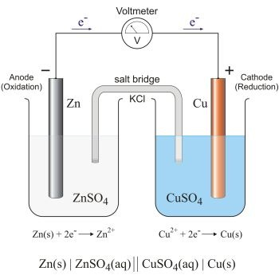

1. ELECTROCHEMICAL CELL 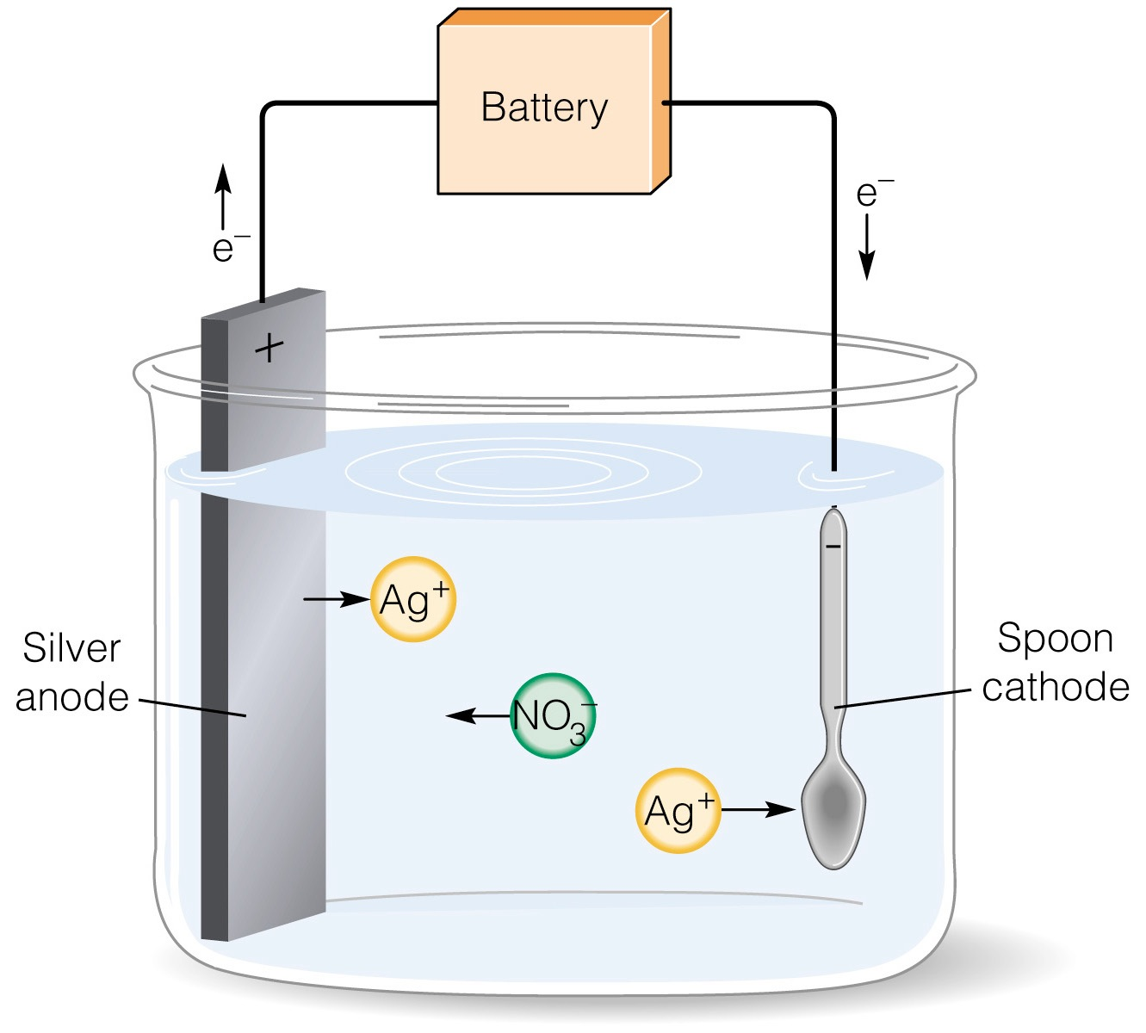

A) VOLTAIC/GALVANIC CELL B) ELECTROLYTIC CELL

*electrochemical cell takes chemical takes chemical energy and produces electricity through a spontaneous chemical reaction

*also known as a voltaic cell, Daniell cell, Galvanic cell or wet cell (today we use “dry cell” which uses an acid paste in AA, AAA and other batteries)

*reduction occurs at the cathode(gains electrons) and always increases in mass (ion to atom); the positive electrode

(RED CAT)

*oxidation occurs at the anode (loses electrons) and always decreases in mass (atom to ion); negative electrode (AN OX)

*electrons flow from anode to cathode

*electrolytic cell uses electrical energy to produce a chemical reaction that would not normally occur; a non-spontaneous reaction is forced to occur.

*negative pole (site of forced electricity and site of metal to be plated) is the cathode (OBJECT SIDE) and positive pole (site of metal used in the plating) is the anode (METAL STRIP SIDE)

*negative ions migrate to the positive electrode (anode) and are oxidized into its ion

*positive ions migrate to the negative electrode (cathode) and are reduced into its atom

REMEMBER: “An Ox and a Red Cat” applies to both electrochemical and electrolytic cells. The difference is an electrochemical cell the anode is negative and the cathode is positive. In the electrolytic cell the cathode is negative and the anode is positive.

Topic #15 Homework Redox and Electrochemistry

Assign oxidation numbers to the elements in the following compounds by filling in the chart appropriately.

|  |  |  |  |
| --- | --- | --- | --- |
| **compound** | **first element** | **middle element** | **last element** |
| **CO2** |  |  |  |
| **SO3** |  |  |  |
| **OF2** |  |  |  |
| **H2O2** |  |  |  |
| **FeCl3** |  |  |  |
| **Na2CO3** |  |  |  |
| **NH4Br** |  |  |  |
| **Cr3(PO4)2** |  |  |  |

Definitions

Pg. 699

4)____________________________________________________________________________

______________________________________________________________________________

______________________________________________________________________________

______________________________________________________________________________

6)____________________________________________________________________________

______________________________________________________________________________

Oxidation-Reduction Reactions

Pg. 709

22) a)________________________________________________________________________

b)________________________________________________________________________

Balance the following half reactions with regard to mass and charge. Write in the appropriate number of electrons to the correct side of the equation **and** fill in any coefficients when appropriate.

a) N2 N3-

b) Al Al3+

c) Br1- Br2

d) Fe3+ Fe2+

e) 2Mn4+ Mn7+

f) H+ H2

g) Ca2+ Ca

h) S4+ S6+

i) Au3+ Au+

j) Cr6+ Cr2+

k) Cl- Cl2

l) S2- S6+

m) N5+ N3-

n) S8 S2-

5. Balance the following redox reaction using the method outlined in the notes.

Al + Fe(NO3)2 Fe + Al(NO3)3

Pg. 711

23) a)

b)

In the diagram below, draw and label a diagram of an electrochemical cell represented by the expression given below. Indicate the following in your diagram.

* metal located at each electrode
* anode and cathode
* charge at each electrode
* direction of electron flow
* half reactions that occur at each electrode
* salt bridge

VOLTMETER

CELL: Fe/Fe2+//Pb2+/Pb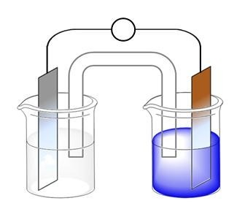

half reaction: half reaction:

__________________________ ________________________

Voltaic/Galvanic Cell vs. Electrolytic Cell

List 4 differences between the two cells illustrated below. First, label each with the type of cell.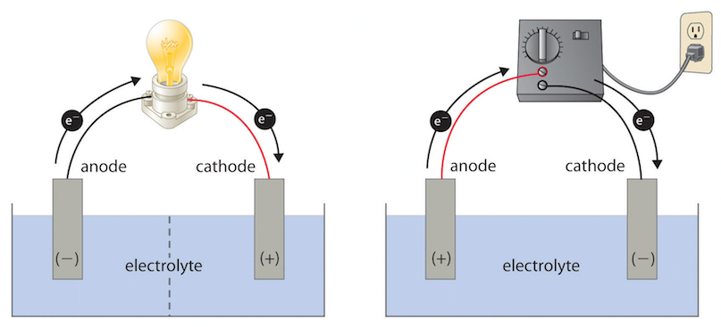

TYPE:________________________________ TYPE:____________________________

1. ___________________________________ 1. ________________________________

_______________________________________ __________________________________

2. ___________________________________ 2. ________________________________

_______________________________________ __________________________________

3. ___________________________________ 3. ________________________________

_______________________________________ _________________________________

4.___________________________________ 4. ________________________________

_______________________________________ __________________________________

Electrochemistry

Pg. 736

2)_________________________________________________________________________

4)________________________

Pg. 754

30)__________________________________________________________________________ ______________________________________________________________________________